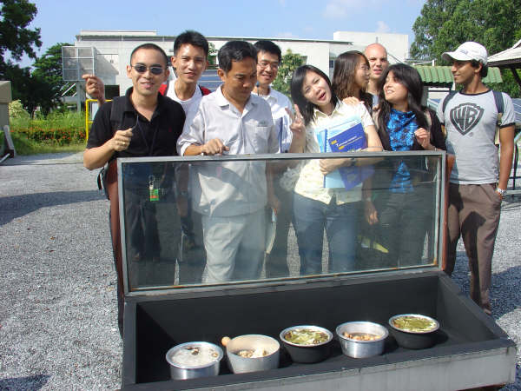
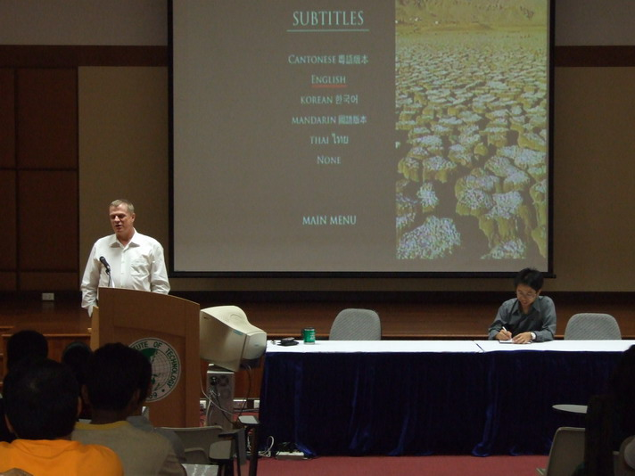
Who should attend?



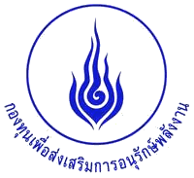

Dr. Weerakorn Ongsakul
Energy Field of Study
Asian Institute of Technology
P.O.Box 4, Klong Luang
Pathumthani 12120
Thailand
Language
Date
The workshop aims for
* Energy Planners * Energy and Environment Specialists * University Teachers and Students * Government and State Enterprise Officers * Power Utility Managers and Engineers
* Institution Researchers
* All interested persons
Registration Fee
Registration is free.
**Deadline to register: 16th MARCH 2009
The working language is English.
The workshop will be held on March 26, 2009
Contact Information
Dr. Weerakorn Ongsakul Energy Field of study Asian Institute of Technology (AIT) Km.42, Paholyothin Highway Klong Luang, Pathumthani 12120 Thailand Tel:+66-2 524-5407 Fax:+66-2524-5439 Website: http://www.serd.ait.ac.th/queenhrd
The 2nd Conference Workshop to Support Development of Human Resource in Energy

To Honor Her Majesty Queen Sirikit

On the Auspicious Occasion of Her Majesty’s

70 Birthday Anniversary

Sponsored by:
The Energy Conservation Promotion Fund

Support by:
Energy Policy and Planning Office (EPPO)

Organize by:
Energy Field of study, Asian Institute of Technology (AIT)

March 26, 2009
Sofitel Centara Grand Hotel,
Central Plaza Ladprao, Bangkok, Thailand


Project to Support Development of Human Resource in Energy
Program Schedule
Please register me for the training workshop on “The 2nd Conference Workshop to Support Development of Human Resource in Energy”
Name:________________________________________
Title:_________________________________________
Company/ University: _____________________________________
Address:______________________________________
Tel: ___________________ Fax: ___________________ e-mail:___________________
Please fax this form to:
Dr. Weerakorn Ongsakul Fax: (66-2) 524-5439
Energy FoS, Asian Institute of Technology Tel: (66-2) 524-5407
P.O. Box 4, Klong Luang e-mail: ______________
Pathumthani 12120, Thailand http://www.serd.ait.ac.th/queenhrd

REGISTRATION FORM
In order to honor Her Majesty Queen Sirikit on the auspicious occasion of Her Majesty's 70th birthday anniversary, the Ministry of Energy through the energy conservation promotion Fund (ENCON) supported 12 Doctoral and 6 Master scholarships in Energy and Energy – related Environmental Studies during 2004 - 2009.
The ENCON Fund has been established under the Energy conservation Promotion Act, on April 3, 1992. During the period 1995-1999, three sub-programs namely Compulsory, Voluntary, and Complementary were established. Complementary program mainly on Human Resource Development, aims at supporting and developing human resources (HR) in the country with the right skills and knowledge in the energy field in order to increase manpower to facilitate effective implementation of ENCON Programs. Main activities of this project consist of the following: the development of curriculum on energy conservation and teaching materials, research grants, seminars, scholarship scheme, and financial support for educational institutes or universities to provide courses related to energy conservation. One of the projects for developing human resources, ENCON Fund and Asian Institute of technology create a project to Support Development of Human Resource in Energy to Honor Her Majesty Queen Sirikit on the Auspicious of Her Majesty’s 70 Birthday Anniversary for study in energy field at AIT in 2002.
In this workshop, the recipients of Queen Sirikit Scholarships both Master and Doctoral students will present their research work.
8:15-9:00 Registration
9:00-9:30 Opening workshop ceremony and photo Session
9:30-9:50 Coffee Break
9.50-10:20 Mayurachat: Regional Energy Resource Development and Energy Security under CO2 Emission Constraint in the Greater Mekong Sub-region Countries (GMS)
10:20-10:50 Chanwit: Optimal Bidding Strategy in Competitive Electricity Market by Improved Particle Swarm Optimization
10:50-11:20 Witoon: Optimal Multiple Distributed Generation Placement in Microgrid by Reinitialized Social Structures Partical Swarm Optimization
11:20-11:50 Purisan: Combined Economic and Emission Dispatch by Augmented Lagrange Hopfield Network
11:50-13:00 Lunch
13:00-13:30 Athavuth: Biomass Gasification Process in Thailand
13:30-14:00 Lerdlekha: Daylighting for Energy Conservation in the Topics: A study on the Influences of Window Configuration and Shading Devices
14:00-14:30 Nopporn: Solar Regenerated Solid Desiccant Evaporative Cooling System
14:30-15:00 Kitti: Voltage Stability Improvement by SVC in Distribution System
15:00-15:30 Coffee Break
15:30-16:00 Saksorn: A Fuzzy Multi-Attribute Decision Making Approach for Multi-Objective Thermal Power Dispatch
16:00-16:30 Chira: Reactive Power Pricing in Deregulated Environment
16:30 Closing of the workshop

