Prof. Buddhima Indraratna, PhD
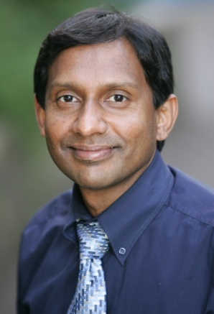
Buddhima Indraratna is a Civil Engineering graduated from Imperial College, London, and obtained his PhD from the University of Alberta in 1987. He has worked in industry in several countries before becoming an academic at AIT during the period 1988-1991, in which he was an Assistant Professor and then Associate Professor. He was involved in a number of major infrastructure projects in Thailand and Southeast Asia during that time. Subsequently, his contributions to the analysis of 2nd Bangkok International Airport (Suvarnabhumi) are well-known and published in major international journals.

Prof Indraratna’s significant contributions to geotechnical and railway engineering have been acknowledged through numerous national and international awards, including the 2016 Inaugural Ralph Proctor Lecture by the International Society of Soil Mechanics and Geotechnical Engineering, the most prestigious award in Transport Geotechnics. In 2009, he delivered the prestigious E.H. Davis Memorial Lecture of Australian Geomechanics Society for distinguished contributions to theory and practice of geomechanics. In 2014, he received the C.S. Desai Medal from the International Association for Computer Methods and Advances in Geomechanics (IACMAG) for outstanding contribution to geotechnical research and education. For his pioneering contributions to Australian railway innovations, he was honoured with the prestigious Business and Higher Education award by the Australian Government in 2009, Engineers Australia Transport Medal in 2011 and 2015 Australasian Railway Society’s Outstanding Individual Award. Over the past two decades, he has also received numerous best paper awards, for example Thomas Telford Premium Award by the Institution of Civil Engineers, UK and Robert Quigley Award by the Canadian Geotechnical Society. He was instrumental in changing the Australian standards the use of vertical drains in soft foundations soils and for revising the standards for railway ballast.

Prof Indraratna currently leads numerous projects funded by the Australian Research Council with over $15 million dollars over the past decade, and he has been a geotechnical consultant worldwide, and a United Nations consultant. He was also an Advisor to the Ministry of Science and Technology (Thailand) for new railway network planning and design, and an Advisor to the Government of Sri Lanka on Post-tsunami rehabilitation of railways. He has more than 550 publications including over 230 reputed journal papers, 9 Books and over 45 invited keynote papers. He has supervised over 50 PhD graduates and 30 Postdoctoral Fellows.

Professor Indraratna is a Fellow of several professional bodies including the most prestigious Australian Academy of Technological Sciences and Engineering (FTSE), as well as a Fellow of several professional organisations including the Institution of Engineers, Australia (FIEAust), American Society of Civil Engineers (FASCE), Australasian Institute of Mining & Metallurgy (FAusIMM) and the Geological Society of UK (FGS).

