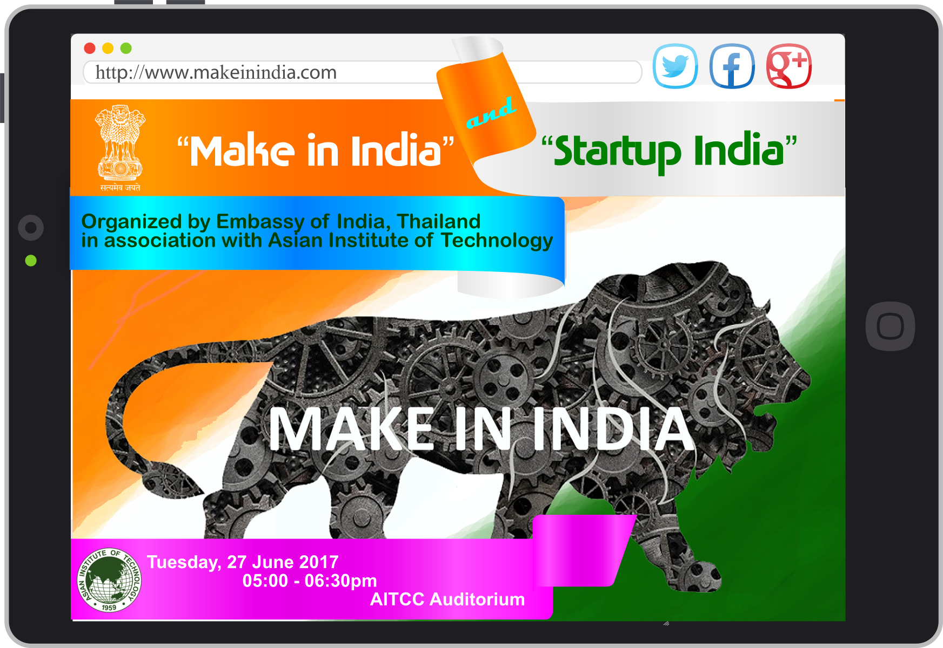

**You are cordially invited to attend a seminar on**

**“Make in India” & “Startup India”**

By Embassy of India, Thailand

Venue: AITCC Auditorium

Time: 5:00 PM – 6:30 PM

Date/ Day: 27th June 2017, Tuesday

Organized by: Asian Institute of Technology

Make in India is a major initiative, designed to facilitate investment, foster innovation, enhance skill development, protect intellectual property and build best-in-class manufacturing infrastructure. There has never been a better time to invest and Make in India. This initiative provides ample opportunities for investors to access the huge Indian market and also gives opportunities to get benefitted by Startup India mission and indulge into entrepreneurship for a brighter future.

This seminar is open to all who are interested.

|  |  |
| --- | --- |
| **Time** | **Activity** |
| 5:00 PM – 5:10 PM | **Welcome**  Prof. Nitin Kumar Tripathi, Director – Special Degree Programs , Camp Coordinator – AIT Education Camp and Study Tour |
| 5:10 PM – 6: 00PM | **Presentation on Make in India and Startup India**  Dr. Sanjay Kumar,  SS(E&C) & Commercial Representative, Embassy of India, Bangkok, Thailand |
| 6:00 PM – 6:20 PM | **Questions & Answers Session** |
| 6:20 PM – 6:30 PM | **Summary & Vote of Thanks**  by Dr. V Rajesh Chowdhary,  Project Associate, AIT- Education Camp and Study Tour |

Looking forward to welcome you!

**Prof. Nitin Kumar Tripathi**

Director- Special Degree Programs, Asian Institute of Technology, Thailand, Email: [nitinkt@ait.asia](mailto:nitinkt@ait.asia) Tel: +6625246392